El Cerrito–Kensington Fire Incident Analysis
Ira Sharenow
July 28, 2025

Introduction
This report analyzes data from the El Cerrito Fire Department. I obtained the data via a Public Records Act request from the California Fire Department.
The data is for the years 2017-2024.
I analyzed data where the fire department was under the auspices of the El Cerrito Fire Department. There are two fire stations located in El Cerrito. The Kensington Fire Station is under contract with El Cerrito, so that data was also included.
https://el-cerrito.org/133/Fire-Department
Important note about the data.
For most of the data, I only counted an incident number one time. So if several fire stations went to an incident or a single fire station brought several pieces of equipment, I still only counted that as one incident.
Except for the last few figures, only incidents in El Cerrito and Kensington were counted.
The last few figures count the work of each fire station. Finally, every row of data is counted in some of the final tables. This will be noted in the comments associated with those figures.
It is also important to note that until the last few figures, I only counted data where an actual street address was provided. So if the address was given as “San Pablo Avenue” or “I-80”, it was not counted. This removed over 10% of the data. For policy decisions, I do not believe the deleted data makes a difference. That data is included in some of the final tables.
El Cerrito changed its fire department numbering. Station 71 became 51. Station 72 became 52. Station 65 became 55. I used the current numbering throughout the report.
This report was created using the R Markdown language in RStudio. The maps are from Google Maps.

Main Takeaways
- Station 51 has about four times the workload of each of the other stations
- Building fires represent a very small portion of the workload
- Emergency Medical Services is the largest segment of the workload.
- The year to year workload varies by a very significant amount
- Seasonal variation was not significantly different
- There were statistically signficant differences for response times based on region – El Cerrito West, El Cerrito East, Kensington

Part 1: Incident Counts
The heat map shows shows where the incidents occurred by frequency. The area around the Del Norte BART Station has a great number of incidents. The area around the El Cerrito Plaza BART Station also had a significant number of incidents.
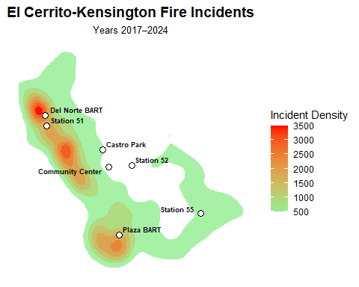

The heat map shows shows where the Emergency Medical Services (EMS, 321) incidents occurred by frequency. The area around the Del Norte BART Station has a great number of incidents. The area around the El Cerrito Plaza BART Station also had a significant number of incidents.
The 321 incidents are a point of emphasis throughout this report. 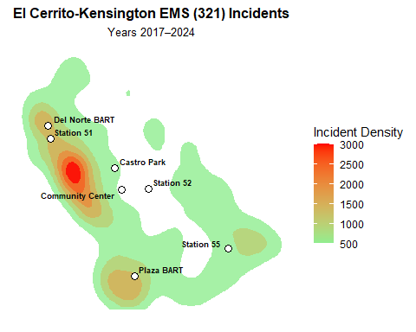

This table is a simple count of the number of incidents that occurred in El Cerrito or Kensington from 2017-2024 that were handled by the three fire stations. About 35% of the calls were EMD (321).
Table 1AE. Total and EMS (Code 321) Incidents (2017–2024)
All Incidents | EMS Incidents | Percent EMS
20,743 | 7,151 | 34.5%

This table breaks down the incidents on an East-West basis The split divide is approximately Richmond Street. Richmond Street and everything west is the West group. East of Richmond Street is in the East group.
Table 1A_EW. Incident Counts by Richmond Street East–West Region
East–West Region | All Incidents | EMS Incidents | Percent EMS
East | 12,021 | 4,428 | 36.8%
West | 8,722 | 2,723 | 31.2%

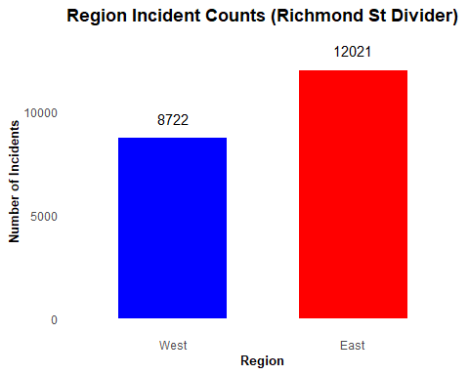

The annual count shows the signfiant variability from year to year. The Covid pandemic was declared in March 2020 and ended in May 2023.
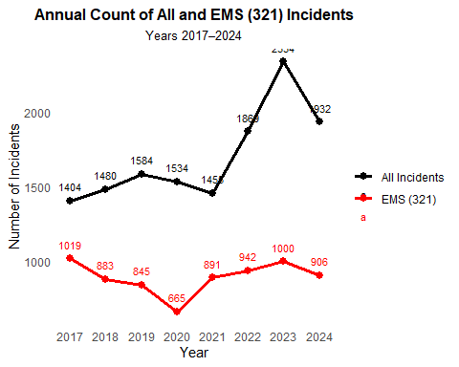

The monthly count of incidents shows that the count peaks in December and January and diminishes during May, June, and July.
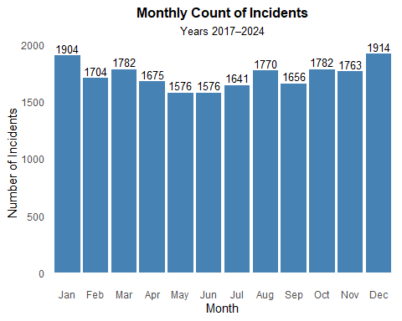

This chart and the next one show that a large number of incidents occur near the two BART stations. We first saw this with the heat maps. Now we see the numbers.
Table 4A. Fire Incidents Within 500 Feet of Key Locations (2017–2024)
Location | Incident Count (within 500 ft)
Plaza BART | 426
Del Norte BART | 892
Castro Park Pickleball | 126
El Cerrito Community Center | 51

Table 4AE. All and EMS (321) Incidents Within 500 Feet of Key Locations (2017–2024)
Location | All Incidents | EMS (321) Incidents | Percent EMS
Plaza BART | 426 | 130 | 30.5%
Del Norte BART | 892 | 234 | 26.2%
Castro Park Pickleball | 126 | 66 | 52.4%
El Cerrito Community Center | 51 | 13 | 25.5%

Part 2: Response Times
Now the report moves from counts to resphis had a signficant effect on the mean but very little effect on the median.
Both the median and the mean tell the same story. Responses are faster to the west of Richmond Street than to the east. I discussed this with a fire captain who said the reason was the terrain. West of Richmond Street is mostly flat and laid out in a grid. East of Richmond Street is very hilly.
Table E2-321. EMS (Code 321) First Response Times by East–West Region
Side | Incident Count | Mean Response Time (min) | Median Response Time (min)
Total | 6,810 | 6.7 | 6.4
East | 4,220 | 7.2 | 6.9
West | 2,590 | 5.9 | 5.6

Table E2-CITY. First Response Times by City and Incident Type
City | Incident Type | Incident Count | Mean Response Time (min) | Median Response Time (min)
El Cerrito | All Incidents | 13,284 | 7.3 | 6.6
Kensington | All Incidents | 2,593 | 8.4 | 7.6
El Cerrito | EMS (321) | 5,516 | 6.5 | 6.2
Kensington | EMS (321) | 1,294 | 7.7 | 7.3

The histogram clearly shows that the West region receives faster response times.
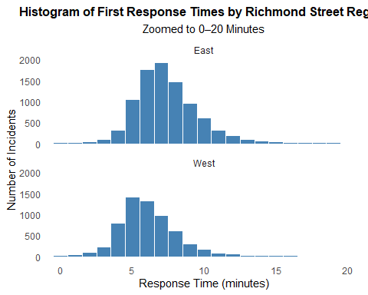

El Cerrito receives faster response times than Kensington.
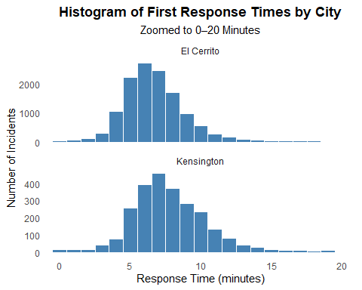

The boxplot continues to tell the same story with respect to response times. El Cerrito West receives the fastest response times. Then El Cerrito East. Then Kensington.
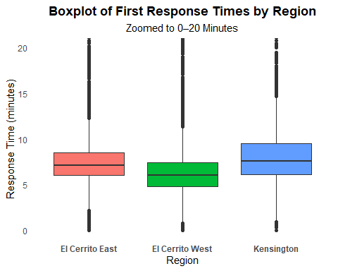

Part 3: Station Level Data
Now the counts include every station that participated in an incident.
The first tables counts the number of incidents that each station participated in.
The Station 51 count far exceeds the count of the other two stations. The EMS percentage of incidents also varies signficantly.
Table E3. Incident Counts by Station (2017–2024)
Station | All Incidents | 321 Incidents | % 321
51 | 14,523 | 4,323 | 29.8%
52 | 3,650 | 1,268 | 34.7%
55 | 4,785 | 1,931 | 40.4%

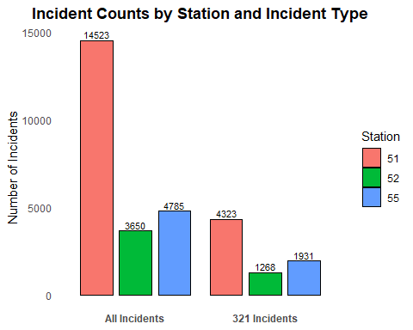

Table E3_REGIONS. Station Incident Counts by Region (With Totals)
Station | EC East | EC West | Kensington | Total
51 | 5,734 | 6,988 | 140 | 12,862
52 | 1,670 | 1,570 | 195 | 3,435
55 | 1,586 | 164 | 2,888 | 4,638
Total | 8,990 | 8,722 | 3,223 | 20,935

The total times on job now looks at every row of data, all activity by the three stations is now included so a station might have several pieces of equipment particpating in an incident. Every piece of equipment was counted. The time starts when the call center receives the call and ends when the last workers leave.
Table E5. Total Time on Job by Station and Year (Hours)
YEAR | 51 | 52 | 55 | Row_Total
2017 | 1,676 | 377 | 535 | 2,587
2018 | 2,603 | 483 | 717 | 3,804
2019 | 2,372 | 595 | 746 | 3,713
2020 | 1,466 | 345 | 511 | 2,322
2021 | 1,368 | 398 | 731 | 2,498
2022 | 1,938 | 464 | 746 | 3,148
2023 | 4,018 | 715 | 1,016 | 5,749
2024 | 2,678 | 669 | 783 | 4,129
Total | 18,120 | 4,045 | 5,785 | 27,950

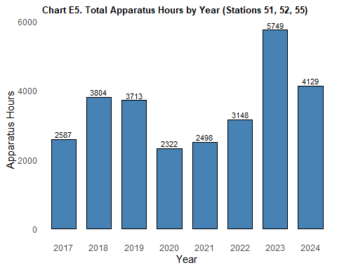

This table shows the activity of the El Cerrito-Kensington Fire Department by city. Interestingly, the spent more hours in Richmond than in Kensington. El Cerrito has a mutual aid agreement with Richmond.
Table E6. Total Apparatus Hours by City and Year (2017–2024)
INCIDENT_CITY_CLEAN | 2017 | 2018 | 2019 | 2020 | 2021 | 2022 | 2023 | 2024 | RowTotal
El Cerrito | 2,230 | 3,316 | 3,241 | 1,920 | 2,001 | 2,686 | 5,024 | 3,611 | 24,029
Richmond | 428 | 417 | 512 | 654 | 690 | 515 | 511 | 541 | 4,268
Kensington | 359 | 492 | 468 | 404 | 499 | 468 | 721 | 518 | 3,929
San Pablo | 43 | 72 | 70 | 140 | 103 | 118 | 86 | 148 | 780
Idylwild | 0 | 732 | 0 | 0 | 0 | 0 | 0 | 0 | 732
Shasta | 0 | 424 | 0 | 0 | 0 | 0 | 0 | 0 | 424
Yreka | 0 | 0 | 0 | 0 | 0 | 0 | 0 | 198 | 198
Orinda | 25 | 17 | 17 | 62 | 26 | 12 | 3 | 25 | 187
Mariposa | 164 | 0 | 0 | 0 | 0 | 0 | 0 | 0 | 164
Pinole | 5 | 19 | 48 | 8 | 47 | 8 | 2 | 9 | 146
**Undefined | 14 | 16 | 6 | 2 | 11 | 12 | 21 | 47 | 129
El Sobrante | 2 | 6 | 9 | 20 | 34 | 7 | 0 | 43 | 121
East Richmond Height | 16 | 21 | 16 | 12 | 22 | 0 | 3 | 13 | 103
Berkeley | 11 | 1 | 11 | 26 | 10 | 11 | 6 | 20 | 96
Hercules | 1 | 17 | 5 | 22 | 13 | 25 | 6 | 0 | 89
Rodeo | 9 | 1 | 0 | 52 | 7 | 1 | 5 | 7 | 82
Crockett | 0 | 0 | 39 | 35 | 0 | 0 | 1 | 0 | 75
Martinez | 0 | 0 | 13 | 1 | 0 | 11 | 1 | 0 | 26
Albany | 2 | 0 | 2 | 2 | 1 | 12 | 1 | 0 | 20
Oakley | 0 | 0 | 16 | 0 | 0 | 0 | 2 | 2 | 20
Contra Costa County | 1 | 4 | 3 | 2 | 5 | 0 | 1 | 0 | 16
Brentwood | 2 | 0 | 0 | 0 | 6 | 0 | 0 | 2 | 10
Antioch | 2 | 0 | 1 | 2 | 1 | 0 | 2 | 0 | 8
Moraga | 0 | 0 | 3 | 2 | 2 | 1 | 0 | 0 | 8
Moraga-Orinda | 1 | 0 | 0 | 0 | 0 | 7 | 0 | 0 | 8
Fairfield | 0 | 7 | 0 | 0 | 0 | 0 | 0 | 0 | 7
Oakland | 0 | 0 | 0 | 0 | 3 | 0 | 0 | 4 | 7
Vallejo | 4 | 0 | 3 | 0 | 0 | 0 | 0 | 0 | 7
Ebrp | 0 | 0 | 5 | 0 | 0 | 0 | 0 | 0 | 5
Suisun City | 0 | 0 | 0 | 4 | 0 | 0 | 0 | 0 | 4
Briones | 0 | 0 | 0 | 0 | 2 | 1 | 0 | 0 | 3
Concord | 0 | 0 | 0 | 0 | 0 | 0 | 3 | 0 | 3
Pacifica | 0 | 0 | 0 | 0 | 0 | 0 | 3 | 0 | 3
Walnut Creek | 0 | 1 | 2 | 0 | 0 | 0 | 0 | 0 | 3
Danville | 0 | 0 | 2 | 0 | 0 | 0 | 0 | 0 | 2
Pittsburg | 0 | 0 | 0 | 2 | 0 | 0 | 0 | 0 | 2
Vacaville | 0 | 0 | 0 | 2 | 0 | 0 | 0 | 0 | 2
Alamo | 0 | 0 | 0 | 0 | 0 | 0 | 1 | 0 | 1
Canyon | 0 | 0 | 0 | 0 | 0 | 0 | 0 | 1 | 1
Clayton | 0 | 0 | 0 | 0 | 0 | 0 | 1 | 0 | 1
Daly City | 0 | 0 | 0 | 0 | 0 | 1 | 0 | 0 | 1
Lafayette | 0 | 0 | 0 | 0 | 0 | 0 | 1 | 0 | 1
Morago | 0 | 0 | 0 | 0 | 1 | 0 | 0 | 0 | 1
San Mateo | 0 | 0 | 0 | 0 | 0 | 1 | 0 | 0 | 1
Santa Rosa | 0 | 0 | 0 | 1 | 0 | 0 | 0 | 0 | 1
Tilden Park (Orinda) | 0 | 0 | 1 | 0 | 0 | 0 | 0 | 0 | 1
Tilden Regional Park | 0 | 1 | 0 | 0 | 0 | 0 | 0 | 0 | 1
Pleasant Hill | 0 | 0 | 0 | 0 | 0 | 0 | 0 | 0 | 0
San Pablo Ave | 0 | 0 | 0 | 0 | 0 | 0 | 0 | 0 | 0
Tilden Park | 0 | 0 | 0 | 0 | 0 | 0 | 0 | 0 | 0
Total | 3,319 | 5,564 | 4,493 | 3,375 | 3,484 | 3,897 | 6,405 | 5,189 | 35,726

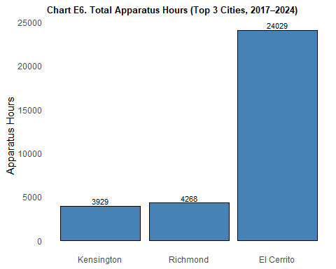

This table clearly shows that the EMS (321) calls is the leading type of calls.
Table E7. Total Apparatus Hours by Incident Type and Year (2017–2024)
INCIDENT_TYPE | 2017 | 2018 | 2019 | 2020 | 2021 | 2022 | 2023 | 2024 | RowTotal
321 EMS call, excluding vehicl | 1,222 | 1,908 | 1,785 | 891 | 1,208 | 1,427 | 1,890 | 1,703 | 12,034
500 Service call, other | 7 | 253 | 904 | 609 | 502 | 515 | 577 | 660 | 4,027
900 Special incident type, oth | 0 | 1 | 9 | 0 | 2 | 354 | 2,275 | 524 | 3,165
611 Dispatched & canceled enro | 327 | 481 | 413 | 319 | 319 | 297 | 361 | 427 | 2,944
111 Building fire | 154 | 222 | 200 | 549 | 382 | 319 | 219 | 499 | 2,544
311 Medical assist, assist EMS | 588 | 701 | 196 | 35 | 43 | 30 | 100 | 24 | 1,717
141 Forest, woods, or wildland | 13 | 1,156 | 16 | 15 | 0 | 0 | 0 | 7 | 1,207
322 Vehicle accident with inju | 137 | 152 | 106 | 111 | 155 | 129 | 135 | 152 | 1,077
142 Brush, or brush and grass | 223 | 38 | 26 | 73 | 48 | 38 | 69 | 44 | 559
571 Cover assignment, standby, | 6 | 1 | 2 | 10 | 0 | 0 | 1 | 351 | 371
444 Power line down | 49 | 5 | 30 | 25 | 29 | 9 | 35 | 115 | 297
554 Assist invalid | 9 | 7 | 33 | 35 | 44 | 69 | 53 | 47 | 297
550 Public service assistance, | 54 | 54 | 43 | 27 | 29 | 22 | 30 | 24 | 283
400 Hazardous conditions – No | 43 | 19 | 26 | 13 | 42 | 16 | 43 | 61 | 263
324 Motor vehicle accident wit | 16 | 35 | 36 | 17 | 55 | 27 | 34 | 12 | 232
743 Smoke detector activation, | 25 | 52 | 34 | 18 | 32 | 27 | 25 | 15 | 228
651 Smoke scare, odor of smoke | 36 | 33 | 26 | 37 | 25 | 18 | 12 | 18 | 205
140 Natural vegetation fire, o | 2 | 0 | 26 | 93 | 12 | 56 | 8 | 3 | 200
150 Outside rubbish fire, othe | 3 | 8 | 9 | 15 | 49 | 39 | 29 | 38 | 190
118 Trash or rubbish fire in a | 4 | 33 | 25 | 27 | 16 | 14 | 22 | 35 | 176
131 Passenger vehicle fire | 7 | 9 | 9 | 28 | 29 | 42 | 39 | 13 | 176
700 False alarms & false calls | 16 | 14 | 33 | 14 | 21 | 25 | 29 | 21 | 173
323 Motor vehicle/pedestrian a | 23 | 32 | 25 | 9 | 17 | 5 | 19 | 36 | 166
622 No accident found at dispa | 8 | 16 | 16 | 21 | 16 | 22 | 26 | 25 | 150
412 Gas leak (natural gas or L | 16 | 13 | 29 | 12 | 19 | 16 | 30 | 11 | 146
151 Outside rubbish, trash, or | 4 | 8 | 11 | 30 | 45 | 20 | 19 | 8 | 145
113 Cooking fire, confined to | 11 | 15 | 20 | 26 | 16 | 16 | 22 | 17 | 143
733 Smoke detector activation | 15 | 17 | 28 | 14 | 18 | 21 | 16 | 14 | 143
735 Alarm system activation du | 20 | 7 | 2 | 11 | 18 | 20 | 19 | 30 | 127
520 Water problem, other | 14 | 11 | 17 | 9 | 11 | 39 | 18 | 7 | 126
553 Public service, not govern | 14 | 9 | 11 | 16 | 17 | 20 | 22 | 9 | 118
440 Electrical wiring/equipmen | 8 | 7 | 28 | 24 | 20 | 11 | 10 | 6 | 114
740 Unintentional system/detec | 13 | 9 | 24 | 15 | 9 | 17 | 14 | 10 | 111
143 Grass fire, includes fire | 22 | 13 | 45 | 2 | 2 | 10 | 6 | 0 | 100
600 Good intent call, other | 38 | 13 | 16 | 8 | 9 | 6 | 7 | 3 | 100
381 Rescue or EMS standby, haz | 15 | 30 | 6 | 26 | 6 | 2 | 4 | 9 | 98
522 Water or steam leak, inclu | 21 | 9 | 11 | 2 | 7 | 14 | 15 | 11 | 90
100 Fire, other | 7 | 17 | 15 | 7 | 3 | 20 | 12 | 4 | 85
445 Arcing, shorted electrical | 8 | 4 | 9 | 7 | 5 | 3 | 29 | 17 | 82
551 Assist police or other gov | 11 | 10 | 14 | 6 | 8 | 20 | 6 | 5 | 80
745 Alarm system activation, n | 8 | 10 | 10 | 10 | 8 | 6 | 12 | 10 | 74
160 Special outside fire, othe | 1 | 0 | 31 | 0 | 21 | 1 | 3 | 6 | 63
320 Emergency medical service | 0 | 1 | 0 | 0 | 2 | 0 | 1 | 59 | 63
552 Police matter | 9 | 4 | 9 | 4 | 4 | 16 | 5 | 4 | 55
744 Detector activation, no fi | 5 | 5 | 2 | 12 | 8 | 6 | 15 | 2 | 55
353 Removal of victim(s) from | 1 | 1 | 11 | 0 | 10 | 13 | 2 | 6 | 44
352 Extrication of victim(s) f | 0 | 10 | 0 | 22 | 3 | 5 | 2 | 0 | 42
112 Fires in structure other t | 0 | 0 | 0 | 25 | 0 | 10 | 2 | 3 | 40
114 Chimney of flue fire, conf | 8 | 10 | 1 | 1 | 2 | 15 | 0 | 3 | 40
132 Road freight or transport | 0 | 2 | 10 | 1 | 22 | 4 | 0 | 0 | 39
300 Rescue and EMS incidents, | 0 | 0 | 4 | 0 | 13 | 8 | 9 | 5 | 39
746 Carbon monoxide detector a | 3 | 5 | 10 | 5 | 4 | 0 | 5 | 7 | 39
161 Outside storage fire on re | 0 | 0 | 0 | 15 | 22 | 0 | 0 | 0 | 37
162 Outside equipment fire | 0 | 0 | 0 | 18 | 12 | 4 | 0 | 0 | 34
710 Malicious, mischievous fal | 4 | 8 | 1 | 2 | 2 | 0 | 7 | 10 | 34
422 Chemical spill or leak | 0 | 0 | 32 | 0 | 0 | 0 | 0 | 0 | 32
730 System or detector malfunc | 1 | 8 | 4 | 6 | 1 | 3 | 4 | 3 | 30
736 Carbon monoxide detector a | 5 | 5 | 3 | 3 | 3 | 1 | 6 | 4 | 30
411 Gasoline or other flammabl | 1 | 9 | 2 | 2 | 3 | 8 | 3 | 1 | 29
812 Flood assessment, no water | 0 | 0 | 0 | 0 | 12 | 2 | 3 | 11 | 28
350 Extrication rescue, other | 1 | 1 | 5 | 0 | 7 | 3 | 10 | 0 | 27
741 Sprinkler activation, no f | 10 | 1 | 3 | 4 | 0 | 8 | 0 | 1 | 27
531 Smoke or odor removal | 10 | 4 | 5 | 1 | 2 | 0 | 1 | 1 | 24
251 Excessive heat, scorch bur | 0 | 1 | 8 | 8 | 1 | 0 | 4 | 1 | 23
154 Dumpster or other outside | 2 | 2 | 0 | 2 | 8 | 2 | 1 | 2 | 19
721 Bomb scare – no bomb | 0 | 9 | 10 | 0 | 0 | 0 | 0 | 0 | 19
424 Carbon monoxide incident | 0 | 1 | 1 | 0 | 3 | 3 | 1 | 6 | 15
511 Lock-out | 2 | 3 | 1 | 2 | 1 | 1 | 3 | 2 | 15
117 Commercial compactor fire, | 0 | 0 | 0 | 0 | 0 | 1 | 0 | 12 | 13
461 Building or structure weak | 1 | 2 | 0 | 0 | 0 | 4 | 6 | 0 | 13
800 Severe weather & natural d | 12 | 0 | 0 | 0 | 0 | 0 | 1 | 0 | 13
122 Fire in motor home, camper | 2 | 0 | 0 | 0 | 9 | 1 | 0 | 0 | 12
542 Animal rescue | 0 | 0 | 0 | 0 | 2 | 3 | 5 | 2 | 12
341 Search for person on land | 0 | 1 | 0 | 6 | 2 | 1 | 1 | 0 | 11
650 Steam, other gas mistaken | 1 | 0 | 0 | 7 | 0 | 0 | 1 | 1 | 10
463 Vehicle accident, general | 2 | 2 | 4 | 0 | 0 | 0 | 0 | 1 | 9
442 Overheated motor or wiring | 0 | 6 | 0 | 0 | 0 | 0 | 1 | 0 | 7
471 Explosive, bomb removal (f | 0 | 7 | 0 | 0 | 0 | 0 | 0 | 0 | 7
653 Smoke from barbeque, tar k | 0 | 2 | 2 | 0 | 3 | 0 | 0 | 0 | 7
213 Steam rupture of pressure | 6 | 0 | 0 | 0 | 0 | 0 | 0 | 0 | 6
413 Oil or other combustible l | 0 | 0 | 0 | 2 | 2 | 0 | 0 | 2 | 6
510 Person in distress, other | 0 | 2 | 0 | 0 | 1 | 3 | 0 | 0 | 6
561 Unauthorized burning | 1 | 0 | 0 | 1 | 1 | 0 | 3 | 0 | 6
734 Heat detector activation d | 0 | 4 | 0 | 0 | 0 | 1 | 1 | 0 | 6
714 Central station, malicious | 2 | 1 | 0 | 1 | 1 | 0 | 0 | 0 | 5
155 Outside or stationary comp | 0 | 0 | 4 | 0 | 0 | 0 | 0 | 0 | 4
331 Lock-in (if lock-out, use | 0 | 0 | 2 | 1 | 0 | 1 | 0 | 0 | 4
410 Combustible/flammable spil | 0 | 1 | 0 | 0 | 1 | 1 | 0 | 1 | 4
460 Accident, potential accide | 0 | 0 | 1 | 0 | 1 | 0 | 2 | 0 | 4
480 Attempted burning, illegal | 0 | 0 | 0 | 2 | 0 | 2 | 0 | 0 | 4
711 Municipal alarm system, ma | 0 | 0 | 2 | 0 | 0 | 0 | 1 | 1 | 4
138 Off-road vehicle or heavy | 2 | 0 | 0 | 1 | 0 | 0 | 0 | 0 | 3
512 Ring or jewelry removal, n | 0 | 0 | 0 | 0 | 0 | 1 | 1 | 1 | 3
521 Water (not people) evacuat | 0 | 3 | 0 | 0 | 0 | 0 | 0 | 0 | 3
911 Citizen complaint, include | 1 | 2 | 0 | 0 | 0 | 0 | 0 | 0 | 3
130 Mobile property (vehicle) | 0 | 0 | 0 | 0 | 1 | 1 | 0 | 0 | 2
351 Extrication of victim(s) f | 1 | 0 | 0 | 0 | 0 | 0 | 0 | 1 | 2
356 High angle rescue | 0 | 0 | 0 | 0 | 0 | 0 | 2 | 0 | 2
441 Heat from short circuit (w | 2 | 0 | 0 | 0 | 0 | 0 | 0 | 0 | 2
555 Defective elevator, no occ | 0 | 0 | 0 | 0 | 1 | 1 | 0 | 0 | 2
652 Steam, vapor, fog or dust | 0 | 0 | 0 | 1 | 0 | 0 | 0 | 1 | 2
671 Hazmat release investigati | 1 | 0 | 1 | 0 | 0 | 0 | 0 | 0 | 2
715 Local alarm system, malici | 1 | 1 | 0 | 0 | 0 | 0 | 0 | 0 | 2
116 Fuel burner/boiler malfunc | 0 | 0 | 0 | 0 | 0 | 1 | 0 | 0 | 1
123 Fire in portable building, | 0 | 0 | 0 | 1 | 0 | 0 | 0 | 0 | 1
133 Rail vehicle fire | 0 | 0 | 0 | 0 | 0 | 1 | 0 | 0 | 1
137 Camper or recreational veh | 0 | 0 | 0 | 0 | 1 | 0 | 0 | 0 | 1
240 Explosion (no fire) | 0 | 0 | 0 | 0 | 0 | 1 | 0 | 0 | 1
621 Wrong location | 0 | 0 | 0 | 1 | 0 | 0 | 0 | 0 | 1
713 Telephone, malicious false | 0 | 0 | 0 | 1 | 0 | 0 | 0 | 0 | 1
813 Wind storm, tornado/hurric | 1 | 0 | 0 | 0 | 0 | 0 | 0 | 0 | 1
163 Outside gas or vapor combu | 0 | 0 | 0 | 0 | 0 | 0 | 0 | 0 | 0
210 Overpressure rupture from | 0 | 0 | 0 | 0 | 0 | 0 | 0 | 0 | 0
340 Search for lost person, ot | 0 | 0 | 0 | 0 | 0 | 0 | 0 | 0 | 0
420 Chemical release, reaction | 0 | 0 | 0 | 0 | 0 | 0 | 0 | 0 | 0
540 Animal problem or rescue, | 0 | 0 | 0 | 0 | 0 | 0 | 0 | 0 | 0
541 Animal problem | 0 | 0 | 0 | 0 | 0 | 0 | 0 | 0 | 0
631 Authorized controlled burn | 0 | 0 | 0 | 0 | 0 | 0 | 0 | 0 | 0
641 Vicinity alarm (incident i | 0 | 0 | 0 | 0 | 0 | 0 | 0 | 0 | 0
712 Direct tie to FD, maliciou | 0 | 0 | 0 | 0 | 0 | 0 | 0 | 0 | 0
Total | 3,316 | 5,556 | 4,493 | 3,374 | 3,488 | 3,898 | 6,404 | 5,185 | 35,714

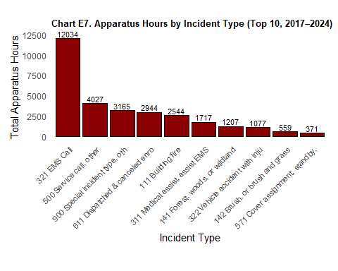

Part 4: Statisitcal Analysis
Analyzing “Monthly Count of Incidents”
Summary for Policymakers: An analysis of monthly fire incident counts in El Cerrito from 2017 through 2024 found no meaningful seasonal patterns. While some months saw slightly more incidents than others, the differences were not statistically significant. This suggests that incident volume is relatively stable throughout the year, and resources should be allocated based on overall demand rather than specific months. Technical Explanation
Technical Explanation: An ANOVA was conducted on monthly incident totals across the years 2017–2024 to test whether mean incident counts varied by month. The result was not statistically significant (F(11, 84) = 1.02, p = 0.434), indicating that monthly differences in incident volume could plausibly be due to random variation. Therefore, no strong seasonal effect is present in the incident data over this eight-year period.

Analyzing Response Times By Region
Policy Audience Explanation We compared emergency response times across El Cerrito East, El Cerrito West, and Kensington. The results show a statistically significant difference among these regions. This suggests that where an incident occurs within El Cerrito or Kensington may influence how quickly responders arrive. Policymakers may wish to explore underlying factors — such as road layout, traffic, or station location — that might contribute to these differences.
Technical Explanation An ANOVA was conducted to assess whether mean first response times differ significantly across three defined regions: El Cerrito East, El Cerrito West, and Kensington. The model used RESPONSE_TIME_MIN as the dependent variable and REGION as the independent factor. The results were statistically significant, indicating at least one pair of regions exhibits a meaningful difference in average response time. Post hoc tests (e.g., Tukey HSD) can be used to identify which region pairs differ.

